A.A.GOVERNMENT ARTS COLLEGE,MUSIRI
Affiliated to Bharathidasan University, Tiruchirappalli

NAAN MUDHALVAN PROJECT -III BSC MATHEMATICS

TOPIC:
POLITICAL JUGGERNAUTS: A QUANTITATIVE ANALYSIS OF CANDIDATES IN THE 2019 LOK SABHA ELECTIONS

Submitted by
TEAM ID:
NM2023TMID08665

TEAM LEADER: P.KEERTHIGA [20468754D3A68818E694E8E312F63BF6]
MEMBERS:
1.D.DHANALAKSHMI [1E9D086A9D7EF03ACF64D72A893AF674]
2. V.DEEPA [28DC3783F3E06A6AAFC44E8CAD0BAA3]

LOK SABHA ELECTIONS 2019
- LokSabha is the house of representatives directly elected by the people. Hence, the LokSabhais called the ‘First House’.
- The members of Loksabha are elected directly by people from the ‘Territorial Constituencies’.
- The Prime Minister is the leader of the LokSabha.
- The first session of this LokSabha commenced on 13 May 2019.
- The tenure of LokSabha is Five Years.
- General elections were held in India in seven phases from 11 April 2019 to 19 May 2019 to elect the members of the 17thLokSabha.
- The LokSabha comprises of a total of 545 seats.
- Elections will be conducted by the Election Commission to fill 543 seats.
- The remaining two seats are filled by nomination of representatives of the Anglo-Indian Community if the President feels that this community has not been represented adequately.
- Votes were counted and the result was declared on 23 May.
- The election result in a landslide victory for the (BJP) which won 303 seats and formed the Government.

EMPATHY MAP
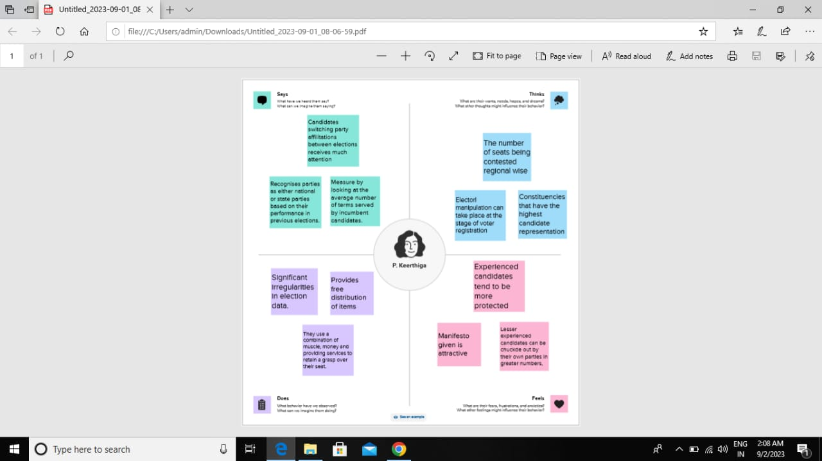
Brainstroming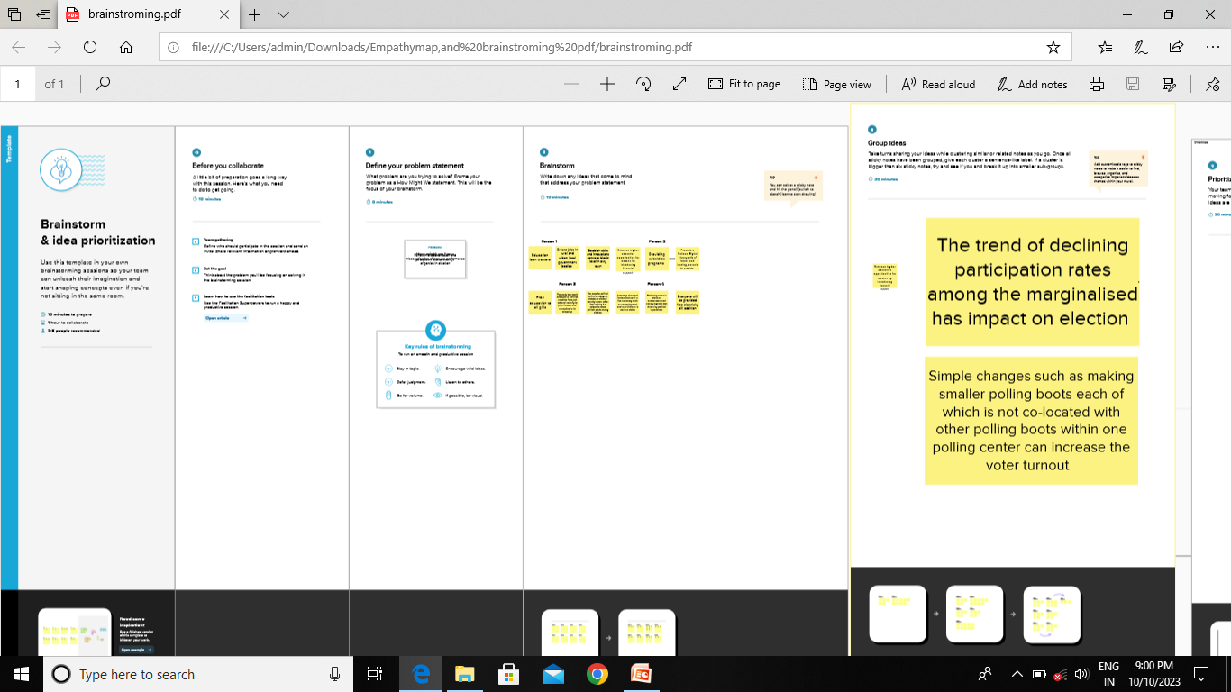

DATA VISUALIZATION
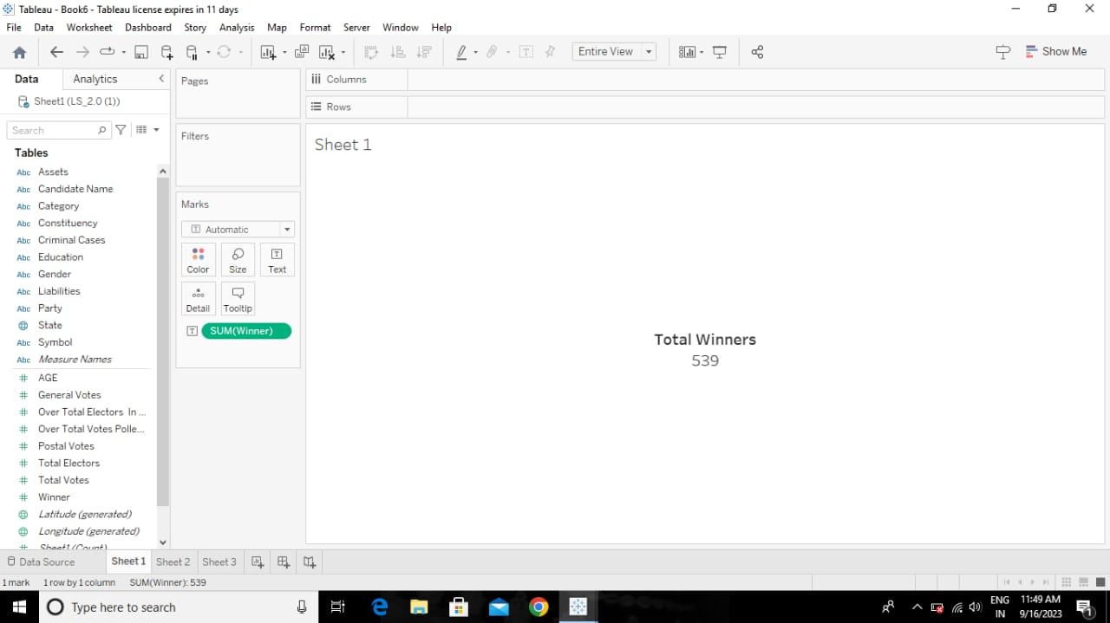
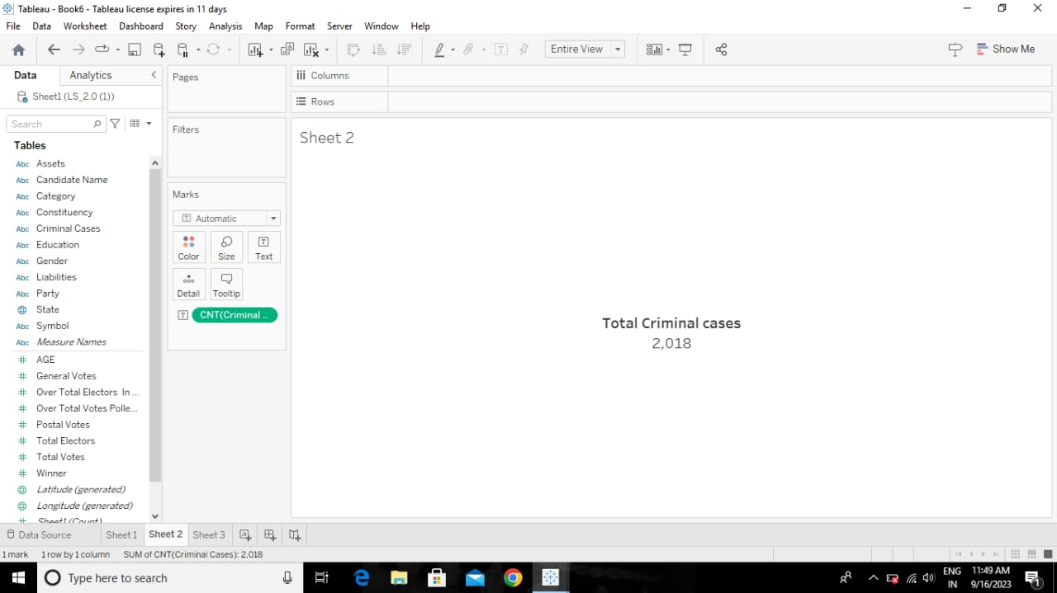

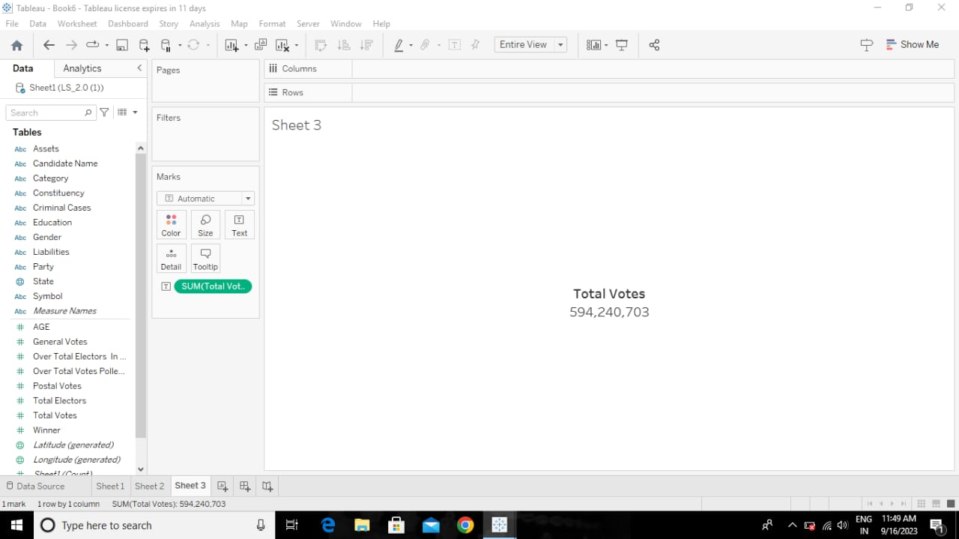
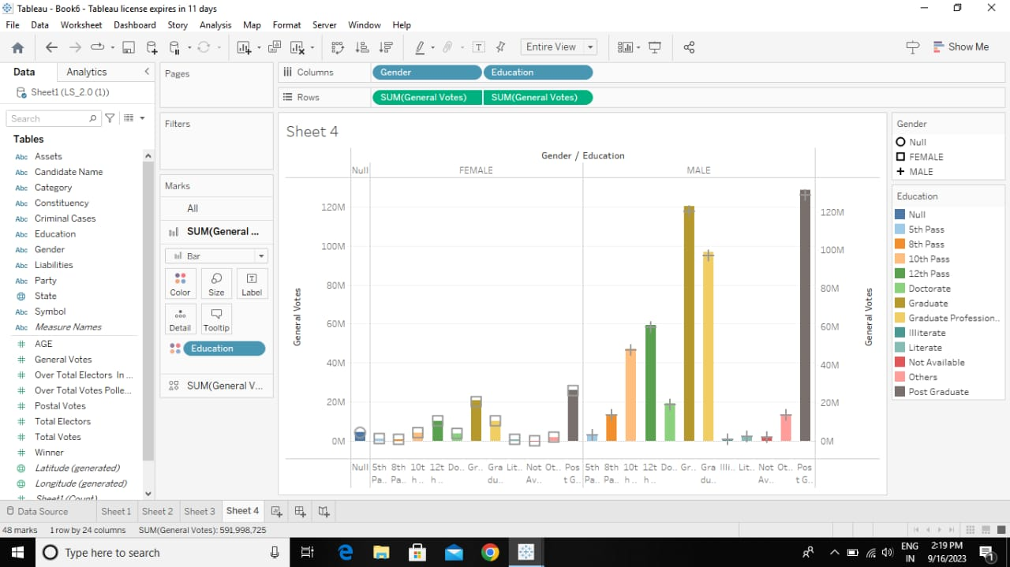

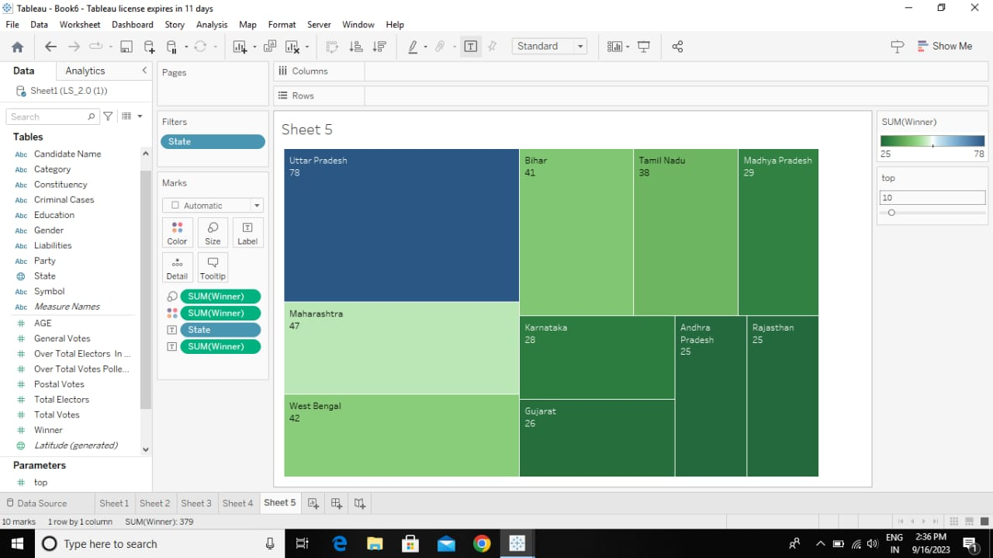
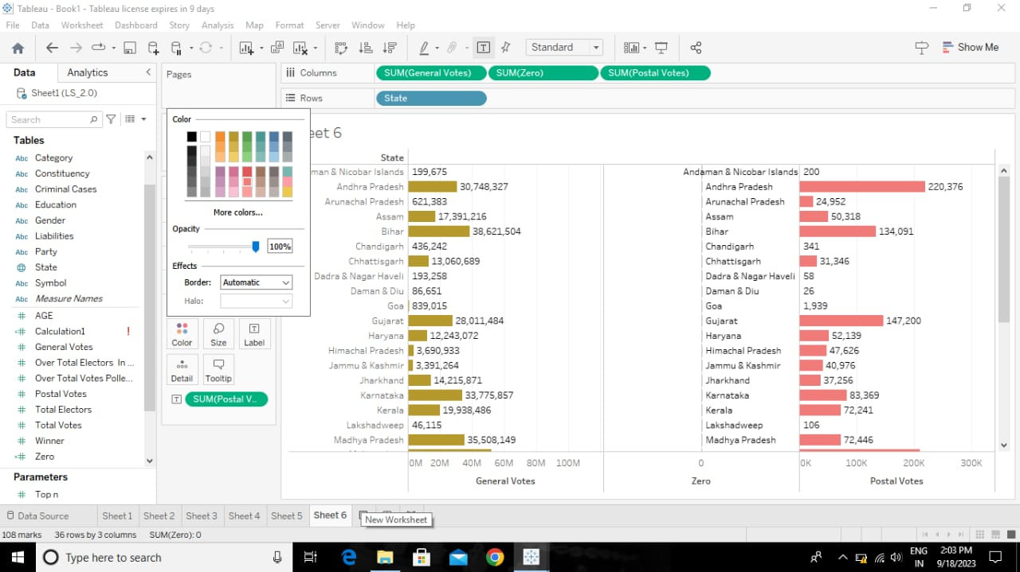

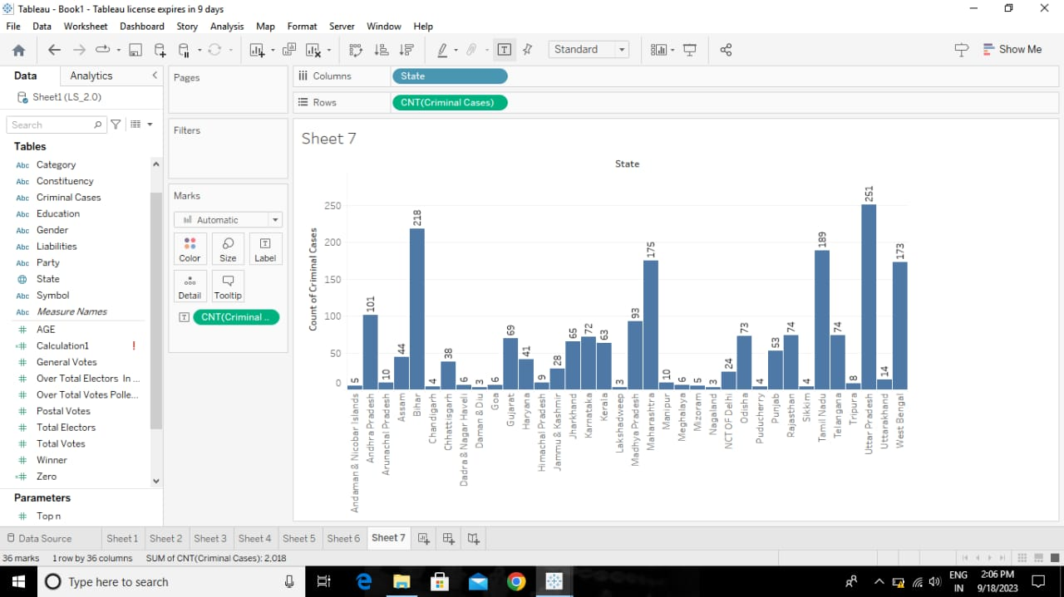
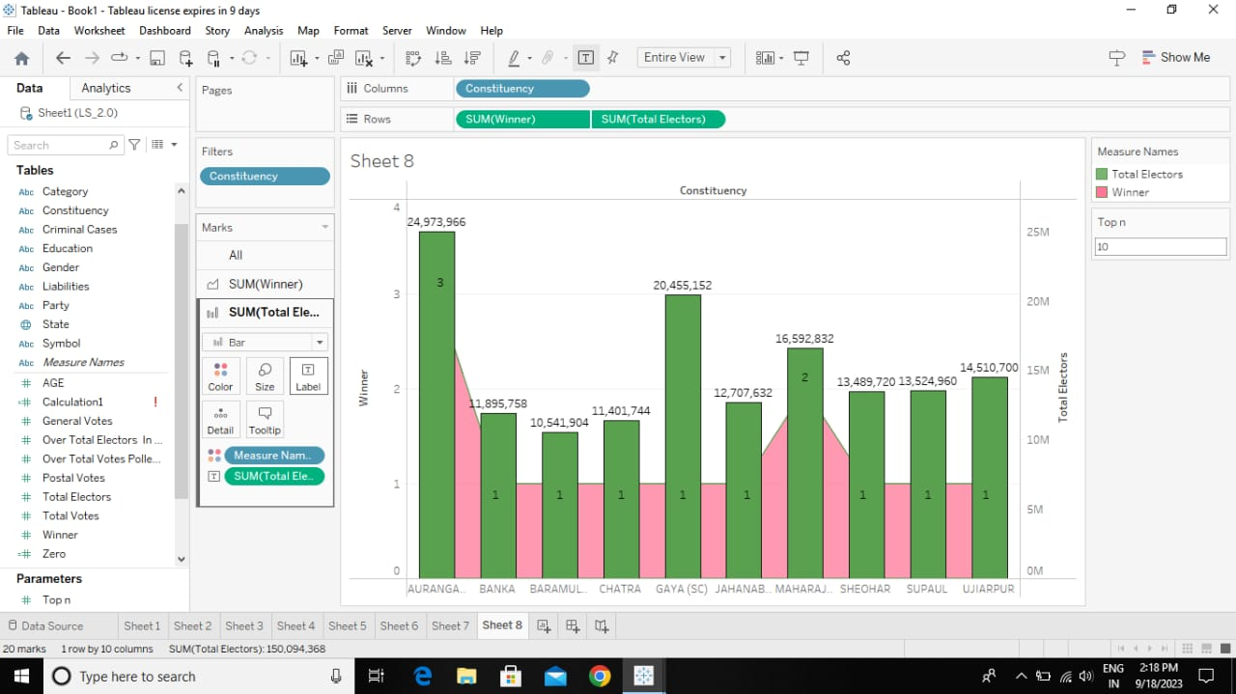

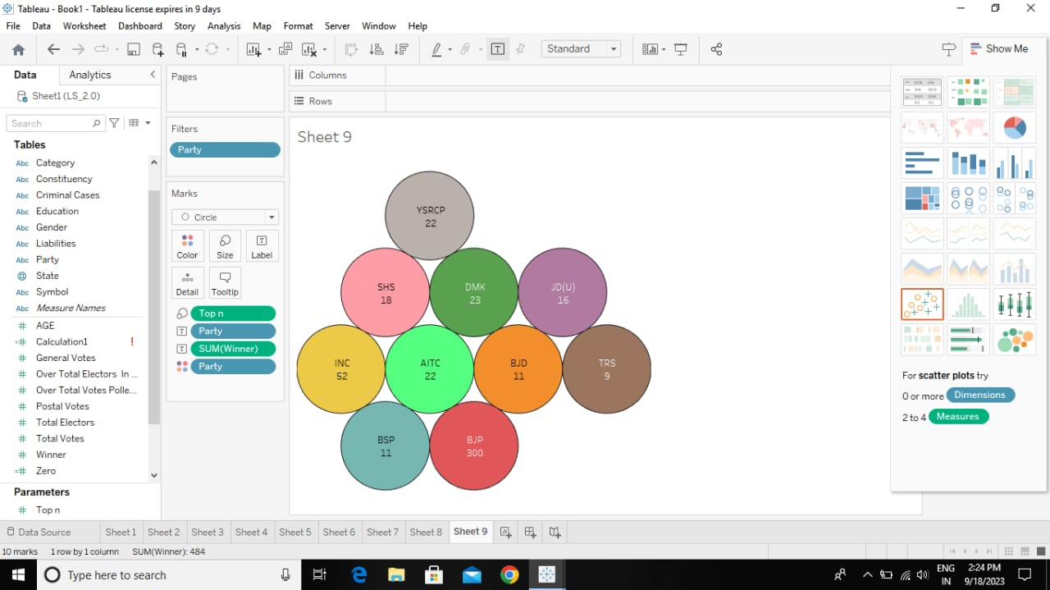
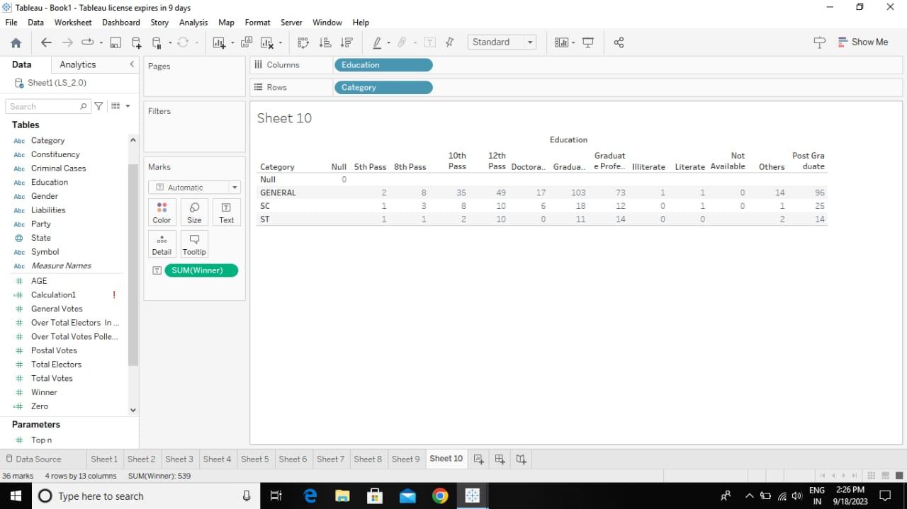
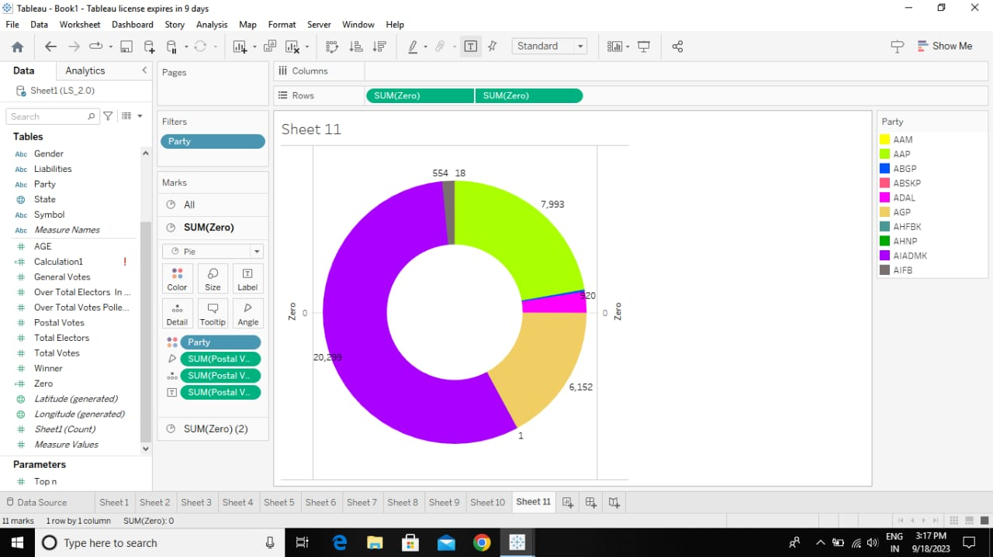

DASH BOARD
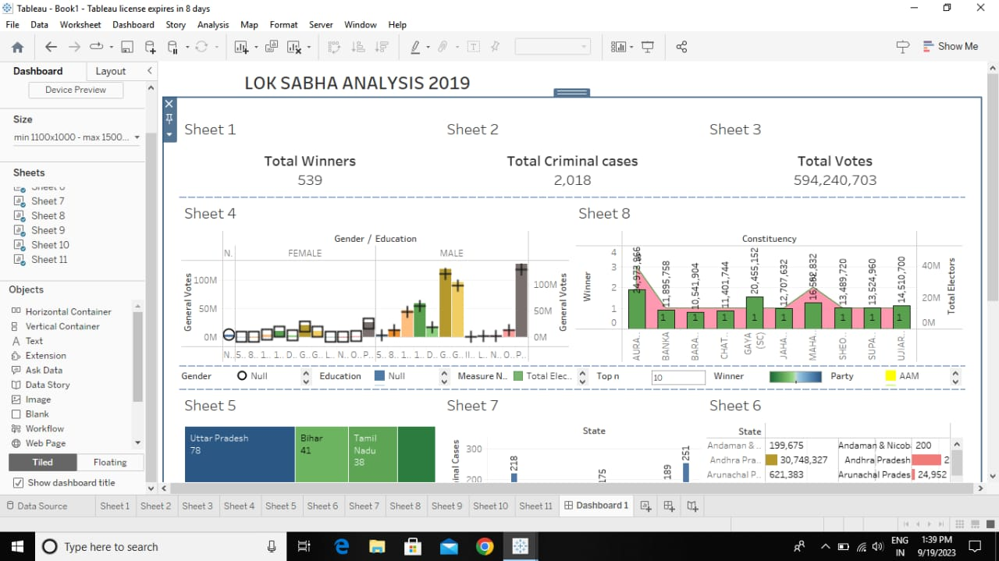
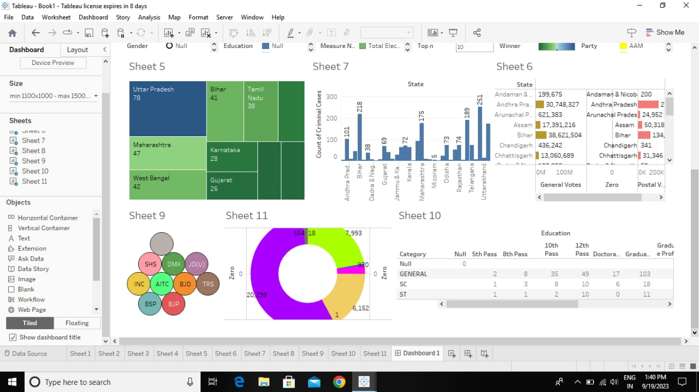
Story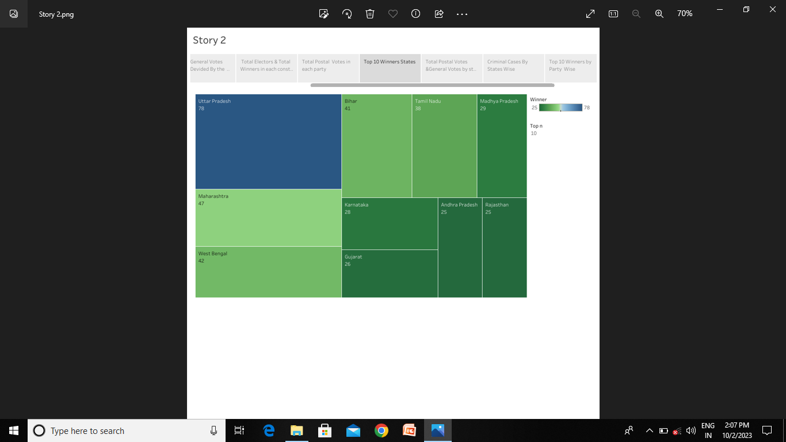

Advantege
- The biggest logic in the favor of the simultaneous election is the saving of government money.
- If country goes for one nation one election it will saving of huge government money.
- As per reports, a whopping Rs 60,000 crore was spend on the 2019 lock sabha election.
- The amount includes what was spend by the political parties fighting the polls and the spending by the election commission of india (ECL) to hold the election.
- The move might also lead to an increase in voter percentage and lesser corruption, besides saving time and energy.
Disadvantage
- It is observed that elections for state assemblies and locksabha are fought on different issues.
- Regional parties target local issues while national parties target national issues.
- So there is a possibility that regional parties will not be able to raise the local issues strongly.
Couclusion
- In Conclusion, the lok sabha is more powerful than the rajya sabha in almost all matters.
- Even in those matters in which the constitution has placed both houses on a equal footing, the lok sabha has more influence due to its greater numerical strength.
- The top executive of the state prime minister is not directly chosen by the people in the parliamentary system, but he is usually the leader of the majority party in parliament.

